IFG Challenge - 3rdYear

Three Week Programme Archery/Mountain Biking/Rafting Physical
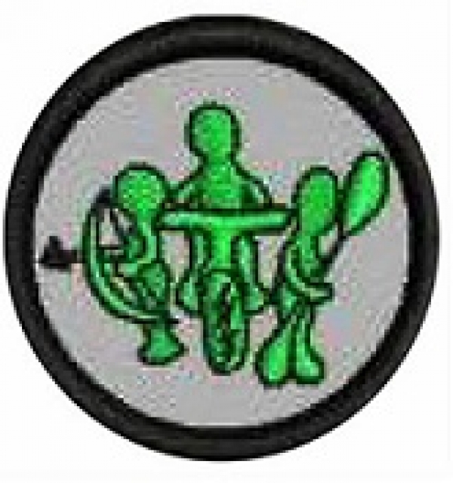
On completion of this three week programme the girls will have earned their Archery/Mountain Biking/Rafting badge.

Aim:
- To teach the girls skills for Archery/Mountain Biking/Rafting to safely pursue these recreational pursuits

Objectives:
- To have the girls learn about equipment necessary for these pursuits

Preparation:
- Organise this subject with the help of a recognized and suitably qualified instructors or use clubs in your area.
- Girls in the Challenge age are likely to be thrill seekers so it is imperative that the right personal are chosen to instruct and oversee these activities.
- Notice to parents about the activity, equipment, place of activity and clothing required.
Teaching Points:
Instruction should cover:
- Equipment
- Maintenance of Equipment
- Instruction - How to use correctly
- Safety – Using the equipment and any extra equipment needed for safety
- Weather conditions
- Clothing

SetUp:
As this subject will be taken away from your usual meeting place, ensure that you have your master roll book with you. Mark the roll before you commence the programme.

Devotion:
Depending on the circumstances you may just wish to open and close the session with a prayer instead of taking a full devotion.

Teaching Session/Activity:
As a qualified instructor will be taking all these sessions it would be expected that all parts of the above teaching points are covered during the three weeks.
It is important that the girls do get an opportunity to practice what they have learned in the sessions.

Notices & home time:

